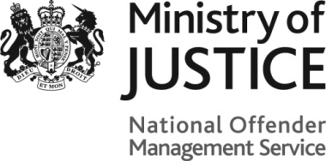
More than the Sum

To be listed on the More than the Sum platform, complete this form and email it to: morethanthesum@socialfirmsuk.co.uk.
For more details on NOMS Social Enterprise Consortia Building Programme go to Contracts Finder.
Completion notes: Delete any highlighted text to input your own.
Organisation name:

Contact details
Name: |  | Job title:
Phone number: |  | Email address:
Main website |  | Other websites
Twitter: |  | Facebook:

Organisation details
Location (town/city, county)
Description (250 characters) | Type a brief description of you organisation here
Area of business(e.g. recycling, cafe, textiles – 50 characters)
Lot/s⁺ interested in: | National  (tick boxes to select) | Regional:  East  East Midlands  London  North East  North West  South East  South West  West Midlands  Yorkshire & Humber |  | Local: Type local areas here, seperated by comma
What we do (450 characters): | More information about your activities
Experience with ex-offenders (450 characters): | Type a brief overview of your experience working with (ex) offenders
Ideal partners (450 characters) | List the type of organisations you would like to partner with (i.e. corporate, voluntary, recycling, manufacturer)
Logo (Click the image to upload your logo – 2MB Max)

